# Homework: ASP.NET MVC AJAX

This document defines the homework assignments from the ["ASP.NET MVC" Course @ Software University](https://softuni.bg/courses/asp-net-mvc/). Please submit as homework a single zip / rar / 7z archive holding the solutions (source code) of all below described problems.

## User Registration with AJAX

Implement "**User Registration**" form, which uses AJAX to **check the availability of the selected username** asynchronously while you type it (after each letter typed). If the username is already in use, an **error message** should be shown right after the username text field:

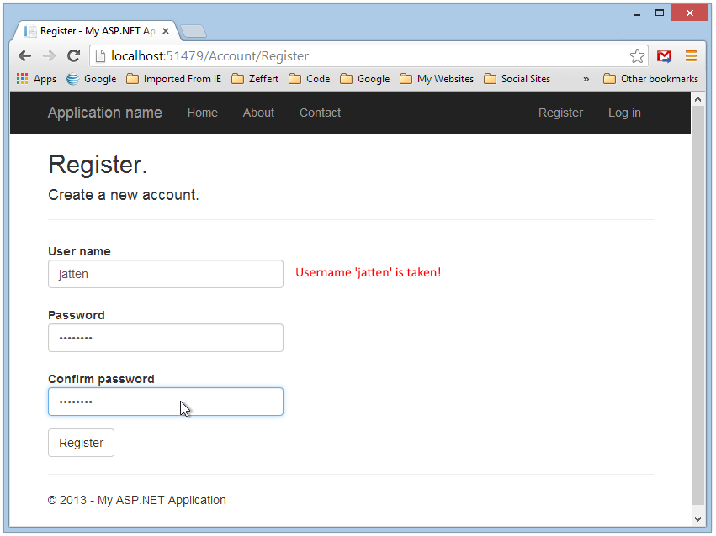

## AJAX Tooltip

Implement a Web page that shows a **list of people**. On mouse over, display additional info in a **tooltip** through **AJAX** call. See the example below to catch the idea. You may embed the image in [image data URL](http://dataurl.net/).



## AJAX Auto-Complete

Create a text box that enters a town name with autocomplete. Load the possible auto-complete town names with asynchronous AJAX call:

